“A computer would deserve to be called intelligent if it could deceive a human into believing that it was human.” - Alan Turing

The date is 7 June 1954. The place is a modest house in Wilmslow, United Kingdom. This is a fictionalized account of true events.

The skinny middle aged man is alone in his empty house. His name is Alan Turing. He is a scientist and a mathematician. He is homosexual at a time and in a place where homosexuality is illegal.

A few years ago Alan was convicted in a British court for ‘Gross Indecency’ after admitting he committed homosexual acts. The judge gave Alan the choice between imprisonment or chemical castration. He chose the latter. Alan must suffer regular injections of a chemical cocktail formulated to suppress his sex drive. It has a wide variety of unpleasant side effects. Alan is miserable. Alan wants to end his existence.

Alan chose a lovely red apple at the market, a luscious fruit worthy of Sleeping Beauty. He always liked Sleeping Beauty. The apple sits on a small table beside his bed. Alan sometimes experiments with cyanide. The apple is laced with cyanide.

Alan invented the mathematics behind digital computers. He helped the Allies break secret German military codes to win World War II. Modern historians estimate that secret work shortened the war in Europe by more than two years and saved over 14 million lives. A fictionalized version of this story is told in the movie The Imitation Game starring Benedict Cumberbatch and Keira Knightley. In 1954 Alan’s work remained a closely guarded military secret.

Alan can no longer work on his beloved science and mathematics. The poison his body must absorb to keep his ‘indecency’ at bay saps his intelligence. He weeps for his unfinished work. Now he can never complete it. Thus did Britain treat its most effective hero of the Second World War.

Computer science advances so rapidly that Alan’s pet computer quickly becomes an obsolete relic. International Business Machines, IBM, builds ever more powerful computers for business and military use.

In 1947 American physicists John Bardeen and Walter Brattain built actual Field Effect Transistors based on Austro-Hungarian physicist Julius Lilienfeld’s 1926 concept. The transistors that replace vacuum tubes get smaller every year. We now call this Moore’s Law. Alan’s intellect lit the way to the Information Age. Others now blaze the trail.

Alan’s last scientific project seeks a path to practical Artificial Intelligence. Years ago Alan realized that digital computers are unsuitable for generating human-level artificial intelligence. He invented them, so he should know. Alan looks instead to nature.
Alan knows that a brain is a biological neural network. The theory of biological neural networks was first proposed and experimentally tested from 1873 to 1898. In 1943 McCulloch and Pitts first formalized Neural Networks as mathematical algorithms. This math is not very difficult. The hard part is understanding how an organism grows into the correct shape. Biological organisms grow brains. An organism’s brain is part of its shape.
Morphogenesis is the biological process by which organisms get their shape. Alan reasons that one who understands Morphogenesis also understands how to grow a brain. Alan starts to follow this path towards Artificial Intelligence.

Alan grew interested in the Morphogenesis problem a few years ago while he worked at Max Newman's Computing Machine Laboratory at the Victoria University of Manchester, England. Alan took a mathematical approach to understanding morphogenesis. This approach is called Mathematical and Theoretical Biology. Alan didn’t solve Morphogenesis but he asked the right questions. Others will follow this path and attempt to answer those questions.

Alan knows that the path to generating practical artificial intelligence involves understanding and emulating Morphogenesis. He can’t prove it, but he is morally certain. If one understands Morphogenesis one ought to be able to grow or emulate an artificial neural network, aka an artificial brain. Alan has no idea how this will work out but he suspects it can be done.

Alan finds the science of Mathematical and Theoretical Biology in a primitive state. Only one notable scientist, Sir D'Arcy Wentworth Thompson, has published much in this field. One of Alan’s published scientific papers, The Chemical Basis of Morphogenesis, reshapes the field. Among other things, Alan’s work correctly predicts the double helix structure of DNA, which was discovered in 1953. Alan Turing leaves the science of Mathematical and Theoretical Biology a more mature, if still incomplete, discipline.

Alan’s poisoned body and brain has failed. He is ready to let go of life. He is ready for the pain and misery to end.

Alan lifts the gorgeous red apple to his lips. He takes a single bite. He relishes the taste of bitter almonds. Alan sets down the apple. As he dies Alan whimsically wonders whether reincarnation might be a thing. He wonders whether some part of him might return for another lifetime in order to complete his unfinished work. Alan Turing dies.

Decades after Alan Turing’s death his wartime contributions finally become known to the public. Royal Air Force (RAF) Captain F.W. Winterbotham published The Ultra Secret in 1975. This book reveals that British codebreakers broke top secret German military codes and thus helped defeat the Nazi war machine. The Ultra Secret tells how Captain Winterbotham distributed this beyond-top-secret intelligence to allied generals. Captain Winterbotham emphasizes how he had to invent plausible false explanations, explanations that did not involve cracking codes, for how allied generals came by this information. The secret spy agency that did this is called Government Communications Headquarters, or GCHQ for short. GCHQ is now a branch of MI-6, the British Secret Service. Winterbotham does not mention Alan Turing’s name and likely had no need to know that name. Thus it is with military secrets. Still, publication of The Ultra Secret caused people to ask questions. Those questions lead to Alan Turing.

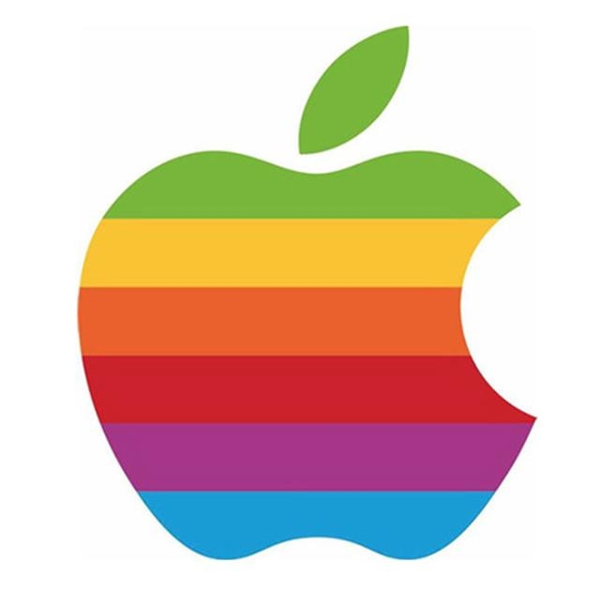
In 1976 a startup computer company names itself Apple Inc . As its logo it chooses a rainbow colored apple with one bite out of it. For those in the know this refers to the death of Alan Turing.

In 2009, following an Internet campaign, UK Prime Minister Gordon Brown makes an official public apology on behalf of the British government for "the appalling way he was treated". Queen Elizabeth II grants Alan Turing a posthumous pardon in 2013. The ‘Alan Turing law’ is now an informal term for a 2017 law in the United Kingdom that retroactively pardons men cautioned or convicted under historical legislation that outlawed homosexual acts.

Since Alan Turing’s death many other scientists have continued Alan’s work in Mathematical Biology. Prominent among them are scientists Stuart Kauffman, Stephen Wolfram, and others who from the 1970s to the present continue Alan Turing’s legacy in Mathematical Biology. Some specific topics include morphogenesis, biogenesis, neural networks, computation, cryptography, artificial intelligence, and even a whole New Kind of Science.

